Discrete Math Test 1 **86/88 A**

1. What is the truth value of (*p* ∨ *q*) → (*p* ∧ *q*) when both *p* and *q* are false?

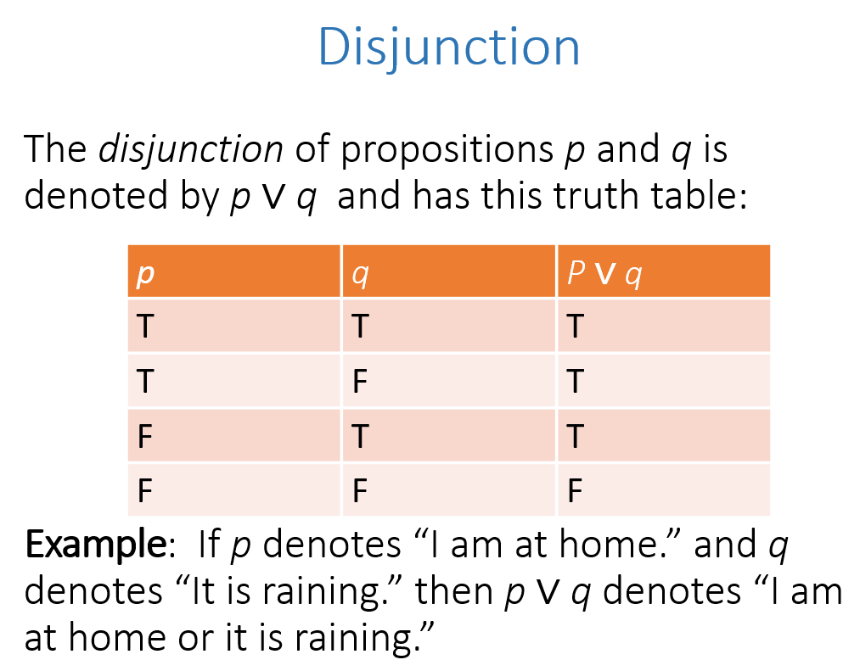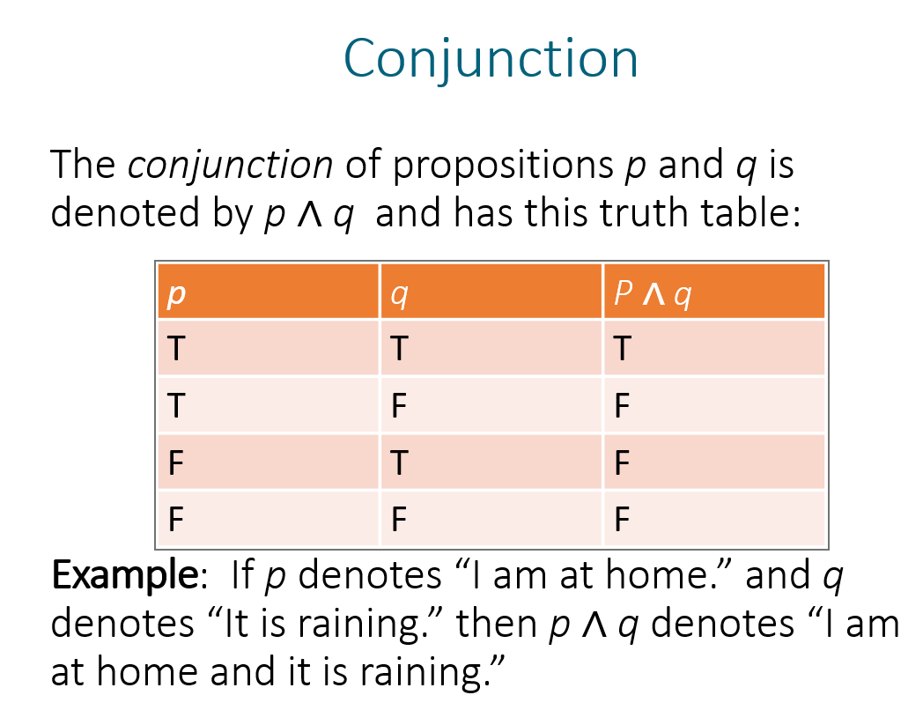

These conjunction and disjunction examples are useful from the slides. Using the bottom row of each of them, we know that both the left and the right side of the implication are false.

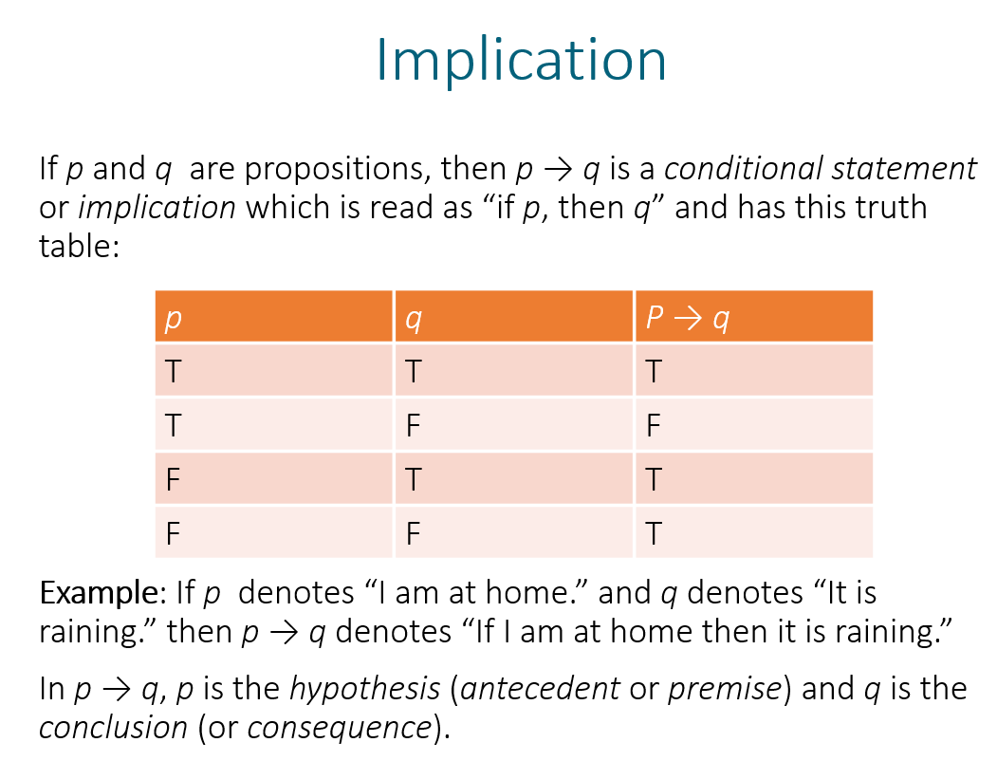

Now moving on to the implication, because I know that I have a left side that is false implying a right side that is also false, the truth value of the entire proposition must be TRUE.

1. Write the converse and contrapositive of the statement “If it is sunny, then I will go swimming.”

Converse: if I go swimming, it is sunny.

Contrapositive: if I do not go swimming, then it is not sunny.

1. Show that ¬ (*p* ∨ ¬*q*) and *q* ∧ ¬*p* are equivalent
   1. using a truth table.

I’ve adapted the truth table that shows that de Morgan’s second law holds to accommodate our example:

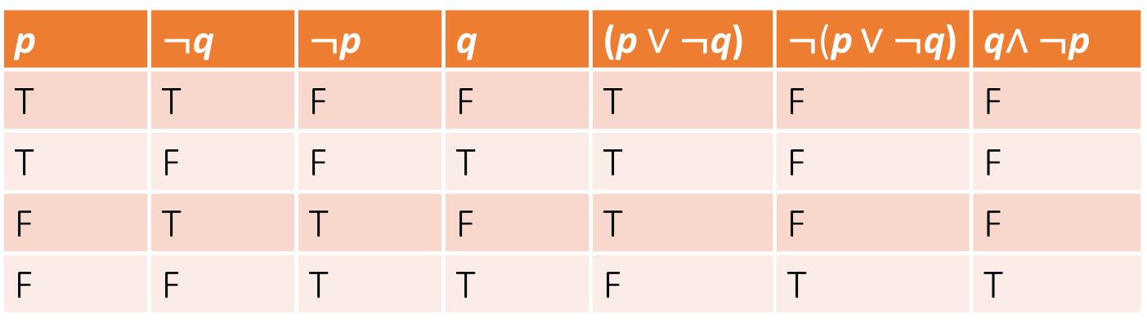

Looking at the far right of the truth table, the final two columns match exactly; this shows that our propositions are equivalent for this problem.

* 1. using logical equivalences.

Using de Morgan’s Laws:



Using the bottom row of de Morgan’s second law and thinking about *q* from the law as *not* *q* in our case, this law proves that the following tautology holds true always:

¬ (*p* ∨ ¬*q*) $≡$*q* ∧ ¬*p*

I could do this with a long elaborate proof as a proof of de Morgan’s law. However, using a simple substitution of terms it is clear that these terms squarely fit this law.

1. Suppose that *Q*(*x*) is the statement “*x* + 1 = 2*x* ”. What are the truth values of

∀*x Q*(*x*) and ∃*x Q*(*x*)?

∀*x Q*(*x*)-- For all of x, Q(x) is FALSE. For example, if x=4, then the left side is 5 and the right side is 8.

However for ∃*x Q*(*x*), the truth value is TRUE. There does indeed exist at least a single value for x that makes Q(x) true. One such value is x=1.

1. Let *P* (*m, n*) be “*n* is greater than or equal to *m*” where the domain (universe of discourse) is the set of nonnegative integers. What are the truth values of

∃*n*∀*m P* (*m, n*) and ∀*m*∃*n P* (*m, n*)?

∃*n*∀*m P* (*m, n*): There does not exist an n that is essentially a greatest integer. This is FALSE.

∀*m*∃*n P* (*m, n*): For all m there does indeed exist an n such that P holds true. For ∀*m*∃*n P* (*m, n*), the value is TRUE.

1. Let *A* = {*a, c, e, h, k*}, *B* = {*a, b, d, e, h, i, k, l*}, and *C* = {*a, c, e, i, m*}. Find each of the following sets.
   1. *A* ∩ *B={a ,e, h, k}*
   2. *A* ∩ *B* ∩ *C= {a, e}*
   3. *A* ∪ *C = {a, c, e, h, I, k, m}*
   4. *A* ∪ *B* ∪ *C={a, b, c, d, e, h, I, k, l, m}*
   5. *A* – *B= {c}*
   6. *A* − (*B* − *C*) *= A-{b, d, h, k, l}= {a, c, e}*
2. Prove or disprove that if *A* , *B* , and *C* are sets then *A* − (*B* ∩ *C*) = (*A* − *B*) ∩ (*A* − *C*).

(you may prove or disprove this any way you want)

Using the sets from question 6:

A -(*B* ∩ *C*)= {*a, c, e, h, k*}-[{*a, b, d, e, h, i, k, l*}∩{*a, c, e, i, m*}]={*a, c, e, h, k*}-{a,e,i}

={c, h, k}

(*A* − *B*) ∩ (*A* − *C*)

(A-B)=c; (A-C)={h, k}

There is no intersection of (A-B) and (A-C), so clearly *A* − (*B* ∩ *C*) does not equal (*A* − *B*) ∩ (*A* − *C*).

In reality *A* − (*B* ∩ *C*) = (*A* − *B*) ∪ (*A* − *C*). This is one of de Morgan’s laws as applied to set theory. The union versus intersect on the second half of the equation is the main difference; once we set it to a union (“or” relationship) then we can prove it’s true!

1. Let *f* (*n*) = 2*n* + 1 . Is *f* a one-to-one function from the set of integers to the set of integers? Is *f* an onto function from the set of integers to the set of integers? Explain the reasons behind your answers.

*f* is indeed a one-to-one function from the set of integers to the set of integers. Each input value produces a distinct output value. In this case, each input will only have one specific output value in the co-domain.

On the other hand, this is not an onto function. Even numbers in the co-domain do not have a mapping from the domain that maps “onto” the even numbers.

Using this interesting children’s rendering of the definition of onto:

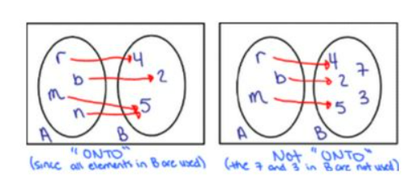

Using this exemplar, in our case here, we would not have red squiggles from the set of integers in set A to any even integer in set B. For that reason, this is not onto.

1. Suppose that *f* is the function from the set {*a, b, c, d*} to itself with *f* (*a*) = *d* ,

*f* (*b*) = *a* , *f* (*c*) = *b* , *f* (*d*) = *c* . Find the inverse of *f.*

In this case because *f* maps every element of the set onto a single element of itself, *f*  is one-to-one; because this mapping is onto itself, *f*  is said to be ”onto”, and by definition *f* is invertible.

A function *f-1* : **B** → **A** is called an inverse function for *f* if it satisfies the following condition:

For every x ∈ **A** and y ∈ **B**, f(x) = y if and only if *f-1*(y) = x… using this definition, here is my answer for question 9:

*f-1(a)=b; f-1(b)=c; f-1(c)=d; f-1(d)=a*

10. Prove or disprove that ***AB*** = ***BA*** whenever ***A*** and ***B*** are 2 × 2 matrices.

False by an example that contradicts... Let A be the 2x2 matrix with 1 in its first row, second column (top right position) and 0 in the other 3 positions. Let B be the 2x2 matrix with a 1 in its first row and first column (top left). In the case of AB, we yield the results below:

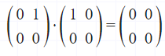

Using the same two matrices and executing the operation of BA, we see different results:

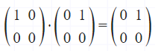

In this case BxA=A. A does not equal the matrix shown in the first step (2x2 matrix of all zeroes). Because of this inequality we have proven that AB does not equal BA for 2x2 matrices.

11. Find a formula that generates the following sequence *a*1*, a*2*, a*3 *. . .* .

(a)5*,* 9*,* 13*,* 17*,* 21*, . . .*

an=(4*n)+1

(b)3*,* 3*,* 3*,* 3*,* 3*, . . .*

*an=3*

(c)15*,* 20*,* 25*,* 30*,* 35*, . . .*

*an=(10)+(5*n)*

12. Describe each of the following sequences recursively: Include initial conditions and assume that the sequences begin with *a*1 . **-2**

*an* = 5*n*

*a1=5*

*an=5*an-1  Not quite:* an+1 = 5an

*an-*1 is not defined for a0

(this is a correct sequence definition but not a recursive definition)

*an* = 1 + 2 + 3 + · · · + *n*

*a1=1*

*an= an-1+n*

an+1 = an + (n + 1)

Same problem as above: you need a base case and an inductive step

13. What is the value of Σ j2 where S = {1,2,3,4}

j є S

Summing across the squares of the elements of S:

12+22+32+42=1+4+9+16=30

14. Each locker in an airport is labeled with an uppercase letter followed by three digits. How many different labels for lockers are there?

Using the product rule, we have 26 letters and then three positions with any one of ten digits 0-9:

$26*10*10*10=26000$ different locker labels possible

15. There are 805 lockers in the athletic center and 4026 students who need lockers. Therefore, some students must share lockers. What is the largest number of students who must necessarily share a locker?

Using the pigeonhole principle, 4026/805= 5 with a remainder… so the largest number of students who must share is 6.

16. Find the value of each of the following quantities.

(a) *C*(5*,* 4):

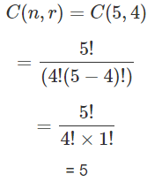

(b) *P* (5*,* 1):

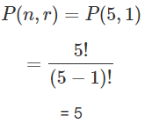

(c) *P* (5*,* 5):

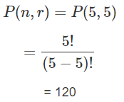

17. How many rows are found in a truth table involving nine different propositions?

There are 29 = 512 rows in a truth table with 9 different propositions. Also there is at least one really cruel discrete math final exam question involving 9 different propositions 😊

18. How many different strings can be made using all the letters in the word *GOOGOL* ?

Of each type of letter, there are 2 G’s, 3 O’s, and 1 L. Creating six-letter strings can be found using

$$\frac{(6!)}{(3!)(2!)(1!)}=60 strings$$

1. How many subsets with an odd number of elements does a set with 10 elements have?

Thinking about the problem, in a subset, there can be 1, 3, 5, 7, or 9 elements. Generally speaking, there are 5 types of subsets with odd-numbered elements that a set of 10 elements can be chopped into. Once you understand this, there are many ways to solve this type of problem. However, since we covered combinatorics in this class, let’s use combinations to solve it. The largest assumption here is that in this case, order doesn’t matter, i.e. the order of the subset within each of our five types of subsets doesn’t matter one bit:



